***Kristina Samoilova Lic.I.S.H. I.S.Hom***

**Registered Homeopath**

**21 taylor hill crescent Balbriggan Co.Dublin**

**0868917287 ksholistichealingforlife@gmail.com**

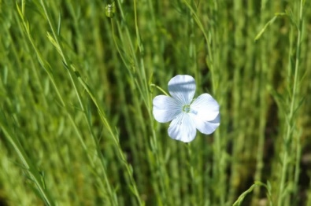

**Children in Homeopathic Treatment**

Parental/guardian consent is required for children aged under 18. Please be advised that all information shared in the consultation is confidential.

Young adults aged 16-18 can attend the consultation on their own (with written consent). I will always endeavour to encourage and facilitate clients under the age of 18 to communicate with their parents/guardians, as this can often help with whatever issues they are experiencing. However, it is important for parents/guardians to know that information shared in the session is confidential and I will not always share it with parents/guardians because ultimately, it will be the young adult’s choice. There are some exceptions to this:

If the child shares that they are self-harming

If the child shares that they feel suicidal or have attempted suicide

If the child shares incidents of criminal behaviour

If the child shares incidents of abuse or bullying

In all these cases, and having told the underage client, the parents/guardians will be informed immediately. Please note the parent/guardian must remain on the premises/ car park/drive for the entire consultation.

I hereby consent to have my child receive homeopathic treatment.

Child’s Name: ________________________________________________

Parent/Guardian Signature: ______________________________________

______________________________________

Practitioner Signature: _______________________________________

Date: ______________________________